Business Insight Report for Superstore
KPI |  |  |  |  |  |  |  |  |  |  |  |  | Value
Total Sales |  |  |  |  |  |  |  |  |  |  |  |  | $2.33 M
Total Profit |  |  |  |  |  |  |  |  |  |  |  |  | $292.30 K
Total Orders |  |  |  |  |  |  |  |  |  |  |  |  | 5,111
Profit Margin |  |  |  |  |  |  |  |  |  |  |  |  | 12.56%
Which region generates highest sales?
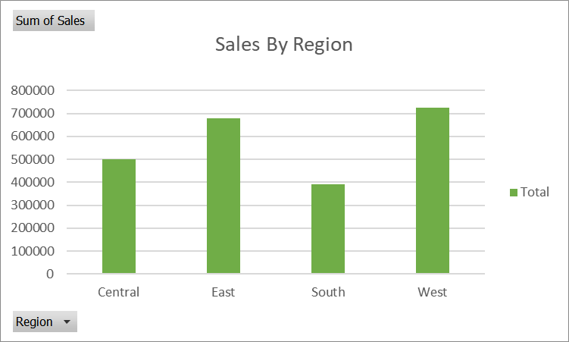
Region | Sales
Central | 501239.9
East | 678781.2
South | 391721.9
West | 725457.8

- The West region contributes the largest share of revenue, with sales of approximately 739.8K.
- The South region has the lowest sales, indicating a potential area for growth initiatives.
- The difference between West and East is relatively small, so comparing their customer segments and product categories could reveal useful strategies.

Which category is most profitable?
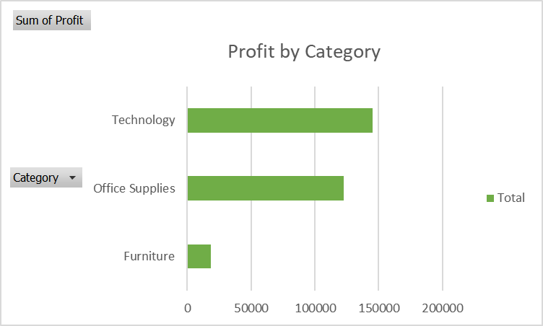
Category | Profit
Furniture | 18451.27
Office Supplies | 122490.8
Technology | 145454.9

- Technology generates the highest profit, making it the strongest category for profitability.
- Office Supplies is the second most profitable category and provides stable earnings.
- Furniture has high sales but much lower profit, which may be due to higher discounts or costs.

Which month perform best?
November
- Sales: 352,665.99 (highest)

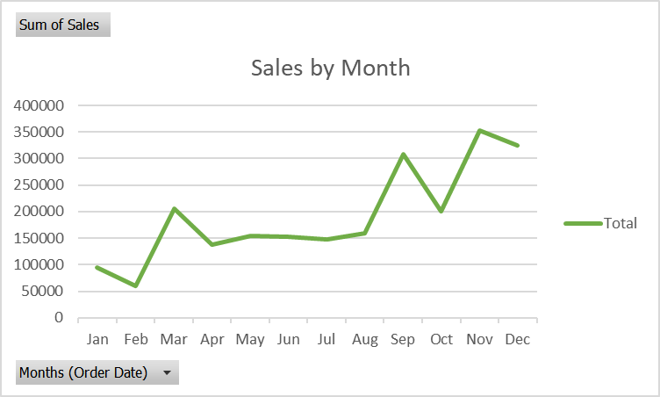

Are discount affecting profit?
Discount |  |  |  |  | Average Profit per Order
0% |  |  |  |  | 66.34
10% |  |  |  |  | 94.79
20% |  |  |  |  | 24.58
30% |  |  |  |  | -45.71
40% |  |  |  |  | -111.53
50% |  |  |  |  | -310.70
70% |  |  |  |  | -95.05
80% |  |  |  |  | -101.55

Key recommendations foe management?
- Strong in Sep–Dec
- Weak in Jan–Feb
- Profit depends heavily on discount control + category mix

